**OBESERVING THE RELATIONSHIP BETWEEN VOLTAGE AND CURRENT WITH HIGH POWERED LASERS UNDER DIFFERENT TEMPERATURES**

Natalie Caro and Aditi Patel

March 11, 2019

Using a Diode Driver and a High-Powered Fiber laser, the current and voltage of the laser were measured and determined to have a linear relationship under a neutral density filter. The current and voltage was measured again using a laser at 45C and the results in this case show that the performance of the laser will decreases as the operating temperature increases or, conversely the performance increases as the operating temperature decreases.

**Introduction**

A laser is a device that emits light through a process called stimulated emission. The term laser is an acronym for Light Amplification by Stimulated Emission of Radiation. Laser light is usually spatially coherent, which means that the light either is emitted in a narrow, low-divergence beam, or can be converted into one with the help of optical components such as lenses [1]. Lasers are used commonly in our daily lives such as in cellphones or barcode scanning and even welding and cutting. It is known that when using any of those devices, the tool could heat up. When a laser begins to increase in temperature, the diode output power tends to decrease [1] thus, affecting the threshold current. The threshold current is the minimum current needed to cause a device to activate. According to Pankove [2], the threshold current has a temperature dependence. If the threshold current can be identified before the performance of the laser begins to suffer, it could help improve the efficiency of the tools by requiring less power to do certain tasks when placed in a temperature-controlled environment.

**Experimental Procedure**

The first part of the experiment, we had to measure the relationship between current and voltage from a high-powered laser. We attached a High-power Fiber Laser and Amplifier to a Newport Laser Diode Driver. We then connected the High-power Fiber Laser to a collimation mount and calibrated it to a SI photodetector 10MHZ Bandwidth 400-1100nm. A Triplett 9015 Digital Multimeter was set to 2V and connected to the Laser Diode Driver. The detector had a collimation tube used to focus all the laser light and to prevent any of the environmental light to interfere with the detection. Behind the detector, we placed a laser trap to capture any remnants of laser light that may get reflected and escape the collimation tube (see **IMG 1**). We set the Laser Diode Driver to 90.8 mA because that was the highest amount of current that would still read 0V from the digital Voltmeter. Then, we increased the current by 60mA each time and recorded the voltage until the current reached 2000mA. The experiment was repeated again except a 2.8 Neutral Density (ND) filter was placed between the laser and the detector. The current was set to 480mA and was increased by 50mA until it reached 2000mA.

In the second part of the experiment, we calculated the affect temperature has on the voltage of a laser. We connected an Extech MN35 Digital Multimeter (DMM) to the Laser Diode Driver to serve as the thermometer. A block of Styrofoam 2.3mm thick was the mount for the High-power Fiber Laser. We set the Laser Diode Driver to 2000mA and immediately recorded the temperature and the voltage. Every 30 seconds, the temperature and voltage were measured until 300 seconds had been reached while keeping the current constant at 2000mA. Afterwards, we let the laser cool down until it reached room temperature before proceeding to the next step. Once cooled, the current was set to 2000mA and kept there until the laser reached a temperature of about 45C. Working quickly, we recorded the voltage of the laser and decreased the current by 100mA each time until the voltage could no longer be detected.

In the final part of the experiment, we set the Laser Diode Driver to Modulation setting and connected it to a HP 54601A Oscilloscope as well as a HP 33120A Waveform Generator. The waveform generator was set to a frequency of 5.6Hz and we observed the waves that appeared on the oscilloscope. The frequency was then changed to 50.6Hz and 150.6Hz and we noted the change in the waves on the oscilloscope.

**Experimental Results**

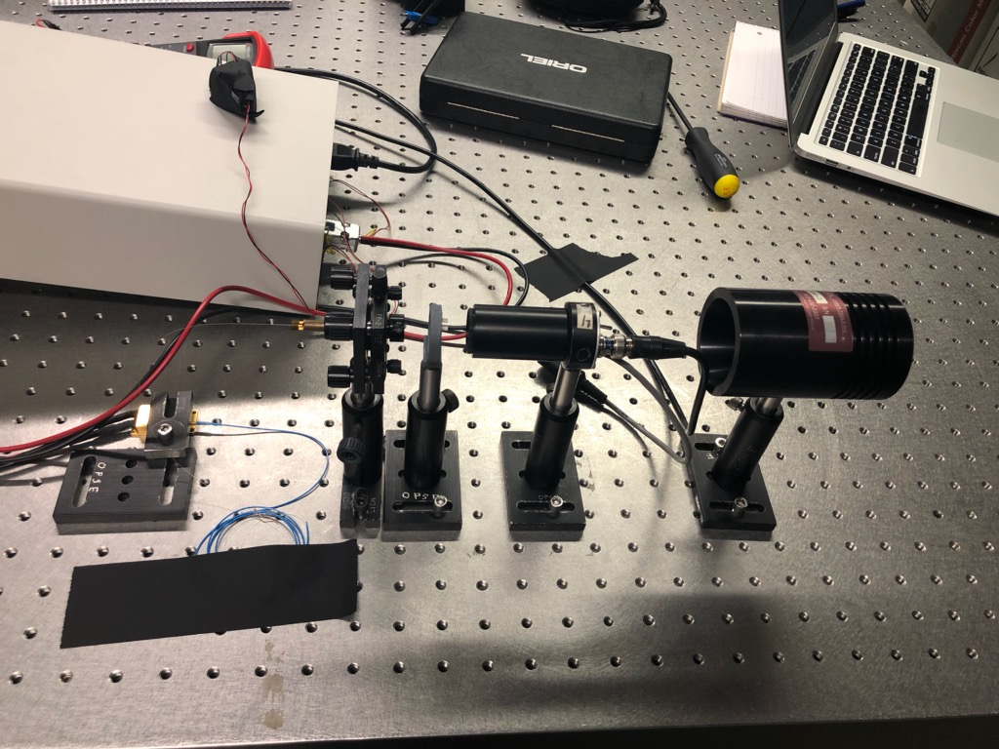

SI Photodetector with collimation tube

Laser Trapper

Neutral Density Filter

Collimation Mount

High-power Fiber Laser

**IMG 1,** Setup for the experiment is presented

During the first part of the experiment, the relationship between current and voltage was observed. In **FIG 1**, the data from the high-powered fiber laser was plotted before and after adding the ND filter. The blue plots represent the measurement of the laser without a neutral density (ND) filter. At approximately 550mA, the laser reached saturation and plateaued. The orange plot represents the measurement of current vs voltage with a 2.8 ND filter. It can also be observed that the current threshold of both the plots starts at around 450mA. The ND filter made it possible to measure the gradual increase from the current threshold to the level of saturation.

**FIG 1**, shows the relationship between current and voltage. The blue plots were measured without a ND filter while the orange plots were measured with a 2.8 ND filter.

When measuring the effect of temperature on the voltage of the high-powered fiber laser, it is important to note that this section is more likely to carry errors due to the nature of fluctuations in temperature from the Extech MN35 Digital Multimeter. **FIG 2** shows how the voltage of the laser steadily decreases as it begins to overheat. In approximately 5 minutes of recording, the voltage of the laser was reduced by half. When the current vs voltage data is graphed on an overheating laser, there is a significant difference from that of a laser that is kept at a safe temperature.

**FIG 2**, shows the relationship between temperature and voltage. The pattern of the plots shows that voltage decreases as temperature increases.

Observing **FIG 3**, the orange dots represent the overheating laser as compared to the room temperature laser represented by the blue dots. Not only is the voltage weaker on the hotter laser, but the current threshold has also increased. The dotted best fit lines show where the current threshold begins at the point where it crosses the x-intercept. On the blue plot, the current threshold is approximately 590mA whereas on the orange plot, the current threshold is 800mA. This demonstrates that when the laser is at a higher temperature, it requires more power to begin functioning just as Pankove had theorized. When performing this experiment, the laser needs to be on a table that can provide thermal stability to maintain a constant temperature for the cooling data.

**FIG 3**, shows the relationship between current and voltage under different temperatures. The blue dots represent the laser at 22C while the orange dots represent the laser at 45C. The overall voltage is weaker at a higher temperature than with a cooler temperature.

In the third part of the experiment, the waveform generator was set to a frequency of 5.6Hz as seen in **IMG 2**. The upper three horizontal bars on the oscilloscope show how the waves of the laser should appear when received by the detector and the waves below it are what the detector is receiving from the laser. In this image, the waveform generator’s frequency is matched by the successful detection of the laser.

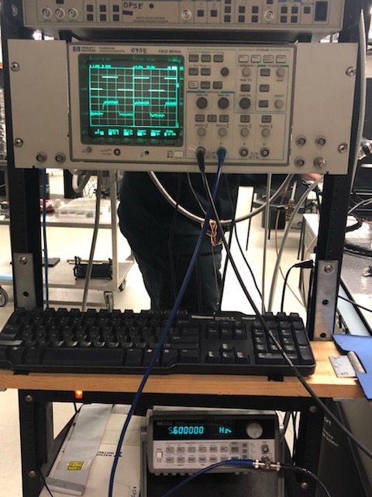

**IMG 2**, Frequency at 5.6Hz the waves are synchronized

Increasing the frequency ten times shows a wave as seen in **IMG 3**. The wave no longer resembles the flat straight lines as it did in the lower frequency. This means that the detector is displaying a form a lag because it cannot keep up with the frequency of the waveform generator.

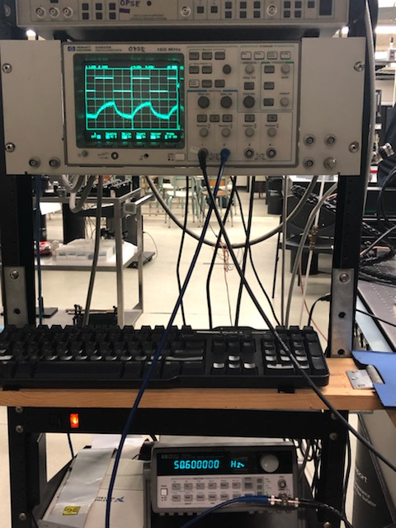

**IMG 3**, Frequency at 50.6Hz the waves are beginning to distort

When the frequency is increased to 150.6Hz, the detector is unable to keep up and the wave is nonexistent as shown in **IMG 4**. This shows that there is a limit to the communication of frequency with a laser and a detector.

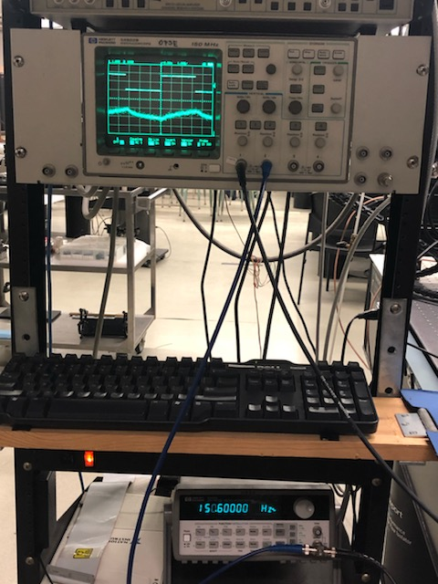

**IMG 4**, Frequency at 150.6Hz the waves are no longer in synch.

**Discussion**

Current and voltage are directly proportional to one another, however, when graphing the data, it isn’t a clear linear relationship without a neutral density filter. Despite using the ND filter, it still isn’t entirely linear. Some factors are the ND filter having fingerprints on it and not being entirely clean and the readings on the DMM also kept fluctuating. When the temperature of the laser was considered in **FIG 3**, the higher temperature of 45C was the initial temperature. By the time the rest of the data was collected, it is possible that the final temperature had increased. **FIG 2**, also encountered the same error with the temperature. In order to gather the data as close to the initial measured temperature as possible, we had to work quickly which led to inaccurate readings of the DMM and not considering the fluctuation. The final result remains unchanged; voltage is indeed decreased when the temperature of the laser increases.

**Conclusion**

As a result of conducting this research, it is suggested to keep the high-powered fiber laser in a cooler environment for optimal performance. When a laser increases in temperature, its voltage is reduced, and the current needed to activate the machine is increased. By performing the experiment that tests the temperature of the laser, it is possible to see the maximum temperature a laser can reach before the voltage is affected. This is essential for providing thermal stability for lasers that are exposed to long periods of work. Lasers that are used specifically for factorial work are at higher risk to overheat than a laser used to scan a barcode because the temperature also depends on the emitted wavelength [2]. As seen in **FIG 2**, in five minutes, the voltage of the laser was reduced by half when the current of the laser was at 2000mA without proper thermal stability. This research successfully explored the affects temperature has on the performance of a high-powered fiber laser.

**References**

[1] Ab-Rahman, M. (2012). The Effect of Temperature on the Performance of Uncooled Semiconductor Laser Diode in Optical Network. *Journal of Computer Science,8*(1), 84-88. doi:10.3844/jcssp.2012.84.88

[2] Pankove, J. I. (1968). Temperature Dependence of Emission Efficiency and Lasing Thresholds in Laser Diodes. *Journal of Quantum Electronics,* *4*, 4th ser., 119-122.